Introduction
Welcome to Wolfenstein: Enemy Territory - the latest game set in the Wolfenstein universe. Players battle in teams as Axis or Allies wage war in a series of linked maps in a brand new campaign mode or over traditional single maps.
Enemy Territory is a Team Game. It rewards co-operation, teamwork and tactics. Enemy Territory is complex. We strongly recommend that you read through this entire manual, as the information contained herein will greatly increase your playing enjoyment and understanding of the battleground.

A. Installing
Enemy Territory is a stand-alone game and does not require Return to Castle Wolfenstein to play. Simply install the game by double-clicking the WolfET file and follow the prompts.
* Microsoft® Windows® 98/ME/2000/XP OS (Windows NT 4.0 not recommended for clients)
* 100% Windows® 98/ME/2000/XP compatible system (including all 32bit drivers)
* Intel® Pentium® III 600Mhz processor or AMD equivalent
* 128 MB RAM
* 32 MB 100% fully OpenGL® compliant 3-D video card
* Microsoft® DirectX® 8.1 or higher (not included)
* 271 MB free hard disk space for game files
* 500 MB free hard disk space for swap files
* 100% Microsoft® Windows® compatible keyboard
* 100% Microsoft® Windows® compatible mouse
* 100% Microsoft® Windows® compatible sound card
* For internet play, 100% Windows® 98/ME/2000/XP compatible 56.6k modem or better internet connection. 56.6k modem play is not recommended for games with more than 8 players total; broadband players should be able to handle up to 32 depending on their connection.

B. Quick Start
B.1 Create a Profile
The first time you run Enemy Territory, you'll be prompted to enter the name of a profile. This profile will store your key configuration, player name, and more. Enter the profile name you wish to be known by online, choose your graphics and mouse options, whether you are Left or Right-handed and set your connection speed. Playing with incorrect connection settings can significantly degrade game performance. When you're happy with your choices, click "Create" to proceed.
B.2 Find a Server
To find a server to play on, click "Play Online" in the main menu. This will bring up the server list. Make sure that "Internet" is selected in the "Filters" section (click "Source" to change it). Click on a server to choose it, enable PunkBuster and then click "Join Server" in the lower right of the browser.
B.3 Review the Objectives
After you've connected to the game, you'll be taken to the Limbo Menu, where you can see the objectives, choose a class and more. On the bottom of the screen you'll see the map objectives. These are what each team has to accomplish to win the game. Clicking the Axis or Allies tab will show you the objectives for that team and you can scroll through them with the arrows to review them. Hit the Play Briefing button to hear an audio introduction to the map.
B.4 Choose a Team and Class
On the top right-hand side of the screen in the Limbo Menu, choose a team (Axis, Allies or Spectator) by clicking the appropriate flag. Then choose a class by clicking one of the class buttons beneath the flag selection (the numbers under each button tell you how many team members there currently are in that class).
Soldiers have the greatest choice of weapons including Heavy Weapons. Medics can heal living players with Health Packs and bring fallen players back into play by reviving them with Syringes. Engineers can construct objectives and also plant explosives like Dynamite and Land Mines. Field Ops resupply their team-mates with ammunition and can call in heavy fire support in the form of Air Strikes and Artillery Strikes. Covert Ops scout out the battlefield, and can steal the uniform of dead enemies in order to infiltrate in disguise. They can also plant Satchel Charges that can be remotely detonated.
Once you've chosen your class, you can choose a weapon from the list beneath the class icons. Some classes have a choice of primary weapons - click the weapon and select from the pop-up list. When you've chosen your weapon, click "OK" to start playing.

C. Playing Enemy Territory
Enemy Territory's maps can be played in a variety of ways, but mainly involve constructing, destroying or taking Objectives. The objectives can be studied in the Command Map by hitting (G) or the Limbo Menu by hitting (L).
To switch to a weapon or tool, press its corresponding number key or cycle to it using the next/previous weapon keys. To use it, press the fire button. Short taps of the Fire button will fire single shots. Hold down the fire button to fire in a long burst or to use a tool for a longer duration.
Players will suffer damage from weapons (their own team's, as well as the enemy's), from falling from height or drowning. Players can be healed by picking up Health Packs, either from a Medic or from a Health Cabinet.
If a player runs out of health, they die. They can now either be revived by one of their team's Medics, or go back into the Limbo menu and choose another team, class or weapons load-out if they wish. Players in Limbo will respawn in the next reinforcement wave at the Spawn Point they've specified in the Command Map.
Players can always check on the status of objectives and their teammates' locations by checking their Command Map (G). The Command Map will also display any battlefield intelligence gathered by their team's Covert Ops.
Players will be alerted to developments on the battlefield by their Command HQ - automated audio messages telling you the state of play and what your next objective is.
Players can also talk with each other, either by typing text messages (using the T Universal Say or Y Team Say keys) or actuating the pre-recorded voice messages in the Voice Chat menu (V).
Players can also form FireTeams to coordinate their tactics. Players can talk to member of their own FireTeam by using the U FireTeam Say key.
Players will be rewarded for good teamplay with Experience Points, extra skills, promotions and medals at the end of the game.
Don't step on the little flags in the ground - they're Land Mines and they'll kill you!
If you find you can't perform an action or fire a heavy weapon, you probably don't have enough Power Bar.
Building Command Posts will help your team to fight effectively. While not the primary goal of your team, building and protecting your Command Post while destroying the opposing team's Command Post will give your team a definite advantage.

D. Movement
Running, Jumping, Crouching, Leaning, Prone and Crawling
Players move around the battlefield by controlling the direction they face with their mouse or using their direction keys to move in that direction.
Holding down sprint (SHIFT) will give you an extra burst of speed. The Stamina Bar shows how much energy for Sprinting or Jumping you have left. Stamina recharges over time.
Accuracy is improved if you Crouch or if you go Prone. You can move while Prone by crawling. When crawling, you can't shoot, change weapons, or reload. If you are crouched, you can double tap Forward (W) to enter the Prone position (This option can be changed in the Options Menu). Leaning (Default Q and E) allows you to peer around corners without unduly exposing yourself. The price of presenting a smaller target is that you cannot fire any weapon while you are leaning.

E. Game Modes
There are four game modes in Enemy Territory, each with their own particular style of play: Objective Mode, Campaign Mode, Stopwatch Mode, and Last Man Standing.
Objective Mode
In the Objective game mode teams must accomplish a series of tasks or objectives to win. These objectives can include everything from taking control of specific points on the map to destroying key installations. A team must complete all the primary objectives in the time limit to win.
Campaign Mode
Campaign mode is a form of Objective mode that allows players to compete against each other in a series of related maps. Players can increase their Rank and Skills over the course of the campaign and carry them from map to map. Skills and Rewards persist from map to map for the duration of the Campaign.
Stopwatch Mode
In Stopwatch mode, teams must accomplish the objectives in the shortest possible time. At the end of a round the teams will switch. The team that was defending will now attack and must now beat their opponents' time from the previous round. Team-switching is not allowed in Stopwatch mode.
Last Man Standing (LMS)
Last Man Standing is a form of Team Deathmatch where players must completely eliminate the opposing team to win a round. Players have only one life. They can be healed with Health Packs from Medics or Health Cabinets, but will not respawn if killed. In LMS there are no skill points, XP does not count towards your score and there are no objectives other than to wipe out the opposing team. There are no Last Man Standing Campaigns.
Respawning, Reinforcements, and Max Lives
In all game modes except Last Man Standing, players will respawn after they die, meaning that they'll come back to life at the team's spawn point with full health and ammo. Players will respawn in reinforcements, or timed waves, that run continuously. The amount of time left until the next reinforcement respawn is shown in the upper left of the screen when a player is killed. The player will only respawn at the next reinforcement period if they've hit the Jump key (Space) before the clock runs out. If the player hasn't hit the jump key, they will stay in limbo and will not respawn. Players can use the reinforcement time to configure their class and weapon in the Limbo Menu.
All game modes apart from Last Man Standing can use the Max Lives option. This option makes the player pay a price for using up all of his lives. The penalty is set to a default three respawn cycles until he can rejoin the fray.

F. The Campaign Map and Limbo Menus

F.1 The Campaign Map
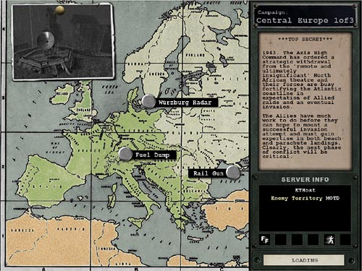
The Map is color-coded by geographical zone, not national boundaries or historical affiliation. North Africa is sandy, Northern Europe is snowy and wet.

F.2 The Limbo Menu
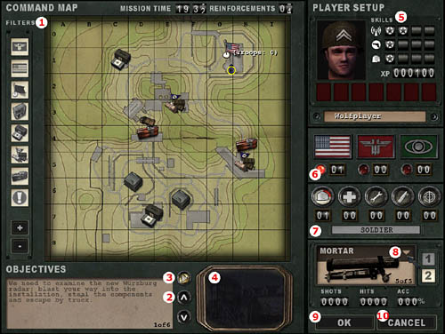
THE COMMAND MAP
This is where you gain information about the battlefield and your mission objectives.
1. Filtering options: Show/Hide Axis, Allied and Capturable Spawns, Constructible Command Posts, Health and Ammo Cabinets, Constructible/Destructible Objectives and any Stealable Objectives.
OBJECTIVES
2. Toggle through Primary and Secondary Objectives: this shows you what each Team must accomplish in the map.
3. Play Audio Briefing: this plays or mutes the Audio Briefing describing the impending battle.
4. Objective Camera: this will show you how each Objective appears in the Map. It is a realtime game camera that shows the status of each objective.
PLAYER SET UP
5. Skills (Battle Sense, Light Weapons, Active Class Skill), XP: Experience Points, Medals won, Profile Name.
6. Team: Allies/Axis/Spectator
You can use Spectator Mode to observe gameplay without participating. The lamp shows which team has been selected. The counters show how many players are on each team.
7. Class: Soldier, Medic, Engineer, Field Ops, Covert Ops
Also includes Active Class Skill level, indicated by quartered backlights. The counters show how many players of each class are on the current team.
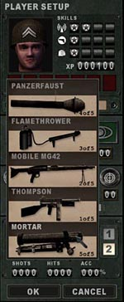 | 8. WEAPON SELECTOR (click to pull out)  - Weapon choice is limited by Class  - 1 indicates Primary Weapon  - 2 indicates Secondary Weapon (usually a pistol)  - Shots Fired, Hits Scored, and Accuracy percentage let you keep track of your accuracy and effectiveness.  - Some servers may have a limit on the number of certain types of weapons that can be chosen.  9. OK: accepts the current Team, Class and Weapon settings and proceeds to the game.  10. Cancel: takes you back to the game without applying any changes.

G. The HUD
The Head-Up Display or HUD displays important information about your player character without obscuring your view of the battlefield around you.
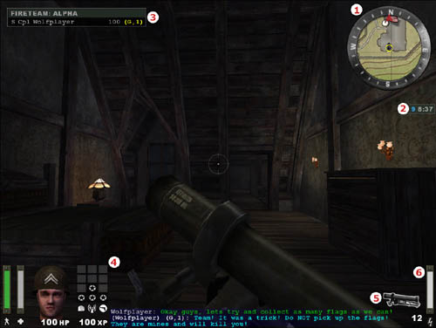

- Compass map
This Compass shows a close-up view of your Command Map, and displays elements on the battlefield such as Land Mines (your team's and spotted enemy Land Mines), fallen team-mates and objectives. Hit (G) to study your Command Map in greater detail.
- Countdown Timer
The Countdown Timer shows how much time has elapsed on that map. Time remaining to the next spawn wave appears in blue.
- Fire Team
Shows the players in your FireTeam.
- Player Info
Avatar of Pain shows general status and Rank. The Health Point Counter shows specific Health. The Health Bar shows relative Health. The Stamina Bar shows if Sprinting and Jumping is possible. The Class Skill Battle Sense and Light Weapons Skill indicator are also shown here.
- Ammo and weapons status
Shows which weapon is equipped and how much ammunition is left in the current magazine.
- The Power Bar
The height of your Power Bar limits how often you can perform certain actions. Power Bar-depleting tasks include Class-specific actions (Field Ops calling in Airstrikes, Engineers planting Land Mines or Dynamite, Medics distributing Health Packs) and firing certain weapons (the Panzerfaust, Mortar and Grenade Launcher).

Hints
Hint Icons appear in the middle of your screen near the crosshair.
Icon | Use
or | Hand  If you can Activate or Use an object, you'll be alerted by the Hand icon. If you cannot use it at that point, you'll see the red circle around the Hand icon.
Ladder
If you can climb up or down something, you'll be notified by the Ladder icon. Look Up and move Forwards to climb up, look Down and move Back to move down.
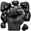 | Breakable  The Breakable icon indicates that you can smash something, with your knife if need be.
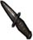 | Backstab  The Backstab icon indicates that you can stab a player from behind, killing them almost instantly.
Constructible
The Constructible icon alerts you that an Engineer on your team can construct an objective on this point.
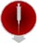 | Revive  The Revive icon appears when you can revive this fallen player by using your Syringe.
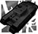 | Tank-Destructible Only  This indicates an objective that can only be destroyed by escorting a Tank up to destroy it with its main gun. See Vehicles.
Dynamite
This indicates an objective that can be destroyed with an Engineer's Dynamite but not with a Covert Ops' Satchel Charge.
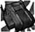 | Satchel Charge  This indicates an objective that can be destroyed with a Covert Ops' Satchel Charge as well as by an Engineer's Dynamite.
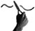 | Disarm  This icon indicates that an engineer can disarm the object with their Tool.
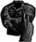 | Steal Uniform  This icon indicates that a Covert Ops can steal a uniform and disguise themselves.

H. Strategic Objectives
There are several different kinds of objective on the battlefield. Some can be constructed, destroyed, captured or only used by one team.

H.1 Team Doors
Team Doors can only be used by players of the appropriate team or an enemy Covert Ops in disguise. The Team Door will remain open for a short time before it closes automatically. You may want to check behind you to make sure no enemy player sneaks in behind you. If you attempt to open an enemy Team Door and you're not a disguised Covert Ops, you'll see this icon.
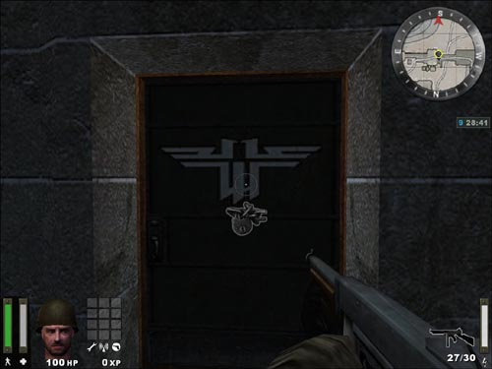

H.2 Constructibles
Some objectives can be constructed by Engineers. These are identified with team-colored flags (or a gray flag for neutral constructibles, which can be constructed by both teams). Engineers can build them by moving to them until the gray "Build" icon is displayed, and then using their Engineer's tool. A blue bar indicates progress. All constructibles can be destroyed with Dynamite, though some can be destroyed with a Covert Ops Satchel Charge.
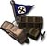 | 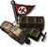 | 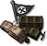
Allied Constructible | Axis Constructible | Neutral Constructible

H.3 Command Posts
Command Posts are of great tactical importance in Enemy Territory. Command Posts help the entire team by speeding up the recharge rate of the players' Power Bars. This allows, for instance, Field Ops to call in more Air Strikes and distribute more Ammo Packs, Engineers to defuse Dynamite more often and Soldiers to fire their mortars more often.
Command Posts are indicated on the Command Map by this icon or . They can be constructed by Engineers and destroyed by Satchel Charges or Dynamite. They are unaffected by Hand Grenades, Rifle Grenades or Flamethrowers.

H.4 Health and Ammo Cabinets
Constructing Command Posts will sometimes also give you an Ammo and Health Cabinet. These contain the same Health Pack and Ammo Packs that are distributed by Medics and Field Ops.
Un-constructed Command Posts and Health and Ammo Cabinets look like this:
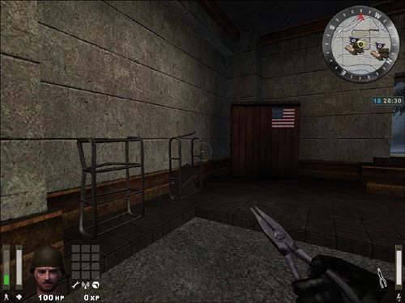
Constructed Command Posts and Health and Ammo Cabinets look like this:
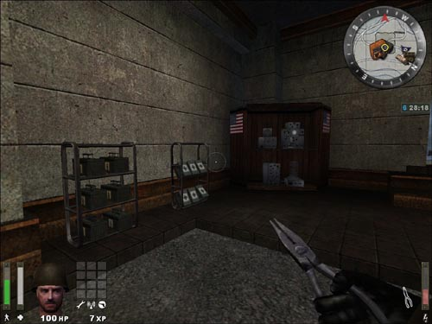

H.5 MG Nests
Emplaced MG's may be existing emplacements, or constructible MG Nests or MG Towers. Gun Emplacements will often be found at strategic locations on the map, usually near key objectives and controlling them can give a team a distinct defensive advantage. These guns - usually protected inside bunkers or behind sandbag walls - can be used by either team. To use them, move behind the gun to bring up the "Activate" icon, and then press Activate (Enter). To disengage, press "Activate" again. These guns can also be damaged and repaired.

I. Vehicles
Vehicles play a critical role in accomplishing the objectives in several of Enemy Territory's maps. Vehicles range from Tanks to narrow-gauge railway Tugs to Trucks. Tanks are needed for their massive firepower against critical point targets. Trucks and railway tugs are used to move critical objects.
Vehicles are marked on the Command Map with a representative icon. The path they travel is also marked on the Command map.

I.1 Escorting Vehicles
You cannot get into a vehicle and drive it. All that is necessary to make the vehicle move is for a player of the same team to move close to it. The vehicle's non-player driver will then be reassured that he can advance, and the vehicle will move on.

I.2 Damaging and Repairing Vehicles
Vehicles cannot be destroyed, only immobilized.
One of the goals of the opposing team is to keep the vehicle stationary to prevent the other team from achieving their objective. To accomplish this, the opposing team can use Panzerfausts, Rifle Grenades, Hand Grenades, Dynamite, Land Mines, Satchel Charges and Air and Artillery Strikes to damage the vehicle. When the crosshair is moved over the vehicle, a health meter will show how much damage the tank has taken.
When the vehicle has taken damage, it must be repaired. Engineers can repair the vehicle by approaching it until the grey "Repair" icon is displayed and then using the Engineer's tool. A blue bar will indicate progress. When the vehicle is repaired and a vehicle-team player is near enough, it will start up and begin moving again. A vehicle can only be repaired after it has lost all of its health.
Once a vehicle has been used to accomplish the corresponding objective(s), it's no longer needed and can't be moved any further. Even after the vehicle has reached the end of its movement its mounted MG will still be usable, so long as the vehicle is in a state of repair.

I.3 Vehicle-Mounted MG's
Tanks sometimes have turret-mounted Machine Guns. To climb into the turret, hit your Activate key (Default F or Enter). You can then fire the Mounted MG by hitting Fire. Turret MGs don't run out of ammunition but they do overheat..

J. Weapons

J.1 Using a Weapon
To use a weapon, select it with one of the keys listed above and then press Fire (left mouse button or the CTRL key). For machine guns or other repeating-fire weapons, hold down the button or key for sustained fire and tap it for shorter bursts. The crosshair will indicate where you're aiming.
- Short bursts or single shots are more accurate and conserve ammunition more effectively than spraying bullets wildly. The longer the burst, the larger your crosshairs will grow and the less accurate your fire will be.
- The Sten MKIIS, Browning .30 MG and MG42 will overheat when used and must cool down after being fired continuously. These weapons will show a small bar near the weapon icon that will turn red when the gun has overheated. Once the weapon cools down it can be fired again.
- Explosive weapons such as Panzerfausts and grenades inflict splash damage on players within their blast radius.
- Head-Shots do much more damage than shots to the body or limbs.
- Helmets absorb weapon damage.
- Sub-Machine Guns and Pistols do less damage when the target is at long range.

J.2 Reloading
Most weapons will eventually run out of ammunition and must be reloaded. To reload, press the (R) key. Be careful not to get caught low on Ammo or reloading when attacked - watch your Ammo and reload when necessary before you find yourself in a firefight.
Once you've run out of a particular type of Ammo, you will not be able to select a weapon using that Ammo until you've picked up some more. Pick up more Ammo from Field Ops, who can give you Ammo Packs, or by touching Ammo Cabinets found on some maps. You can also get more Ammo for your weapon by running over weapons dropped by other players, provided they use the same type of Ammo.

J.3 Swapping Weapons
You can swap your weapon for any weapon your class can use by moving up to it and using your Activate key (Enter).

J.4 The Weapons

Single-Handed Weapon (Keyboard 1 or 2)
All player classes are equipped with the combat knife and a Pistol as a Secondary Weapon. They are generally used only when short of ammunition for the player's Primary Weapon.
Knife (Keyboard 1)
The knife is the most basic weapon and is generally used as a last resort when you run out of ammo, or if you want to kill your enemy silently.
 | Pistol (Keyboard 2)  All Allied soldiers carry a Colt .45 pistol, while Axis soldiers carry a Luger 9mm. The Covert Op class is the only class that carries a pistol with a silencer.
  Colt .45 ACP | Luger 9mm

Two-Handed Weapon (Keyboard 3 or 0)
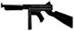 | M1A1 Thompson or MP40  The Medic and Field Op classes carry a sub-machinegun in this slot - Allied players carry the M1A1 Thompson machine gun while Axis players carry the MP40. All other classes have a choice of two-handed Primary Weapons to carry in this slot.
  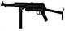
  M1A1 Thompson | MP40
 | M1S Garand or K43 (Silenced)  Both of these specialized sniper rifles are equipped with fixed silencers and scopes. Alt-Fire (Z) will switch to scope view, while Zoom In (=) and Zoom Out (-) will change the view. Weapons with Zoomed-In scopes will appear less steady when aiming. The bar to the left of the crosshairs will determine how steady the weapon is (green is most steady, orange is moderately steady, and red is not steady). Firing when Crouched or Prone helps to steady the weapon.
  M1S Garand | K43
FG42
This weapon combines the accuracy of a scope with the full-auto potential of a Sub Machine Gun. Alt-Fire (Z) zooms the scope. Full-Auto fire is not possible while zoomed-in.
Sten MkII S
This submachinegun fires very accurately without the need of a scope. It is also extremely quiet and doesn't require a silencer. Its only drawback is the fact that it overheats very easily so care must be taken to use short bursts.
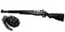 | M1 Garand + M7 Grenade Launcher  The Engineer's M1 Garand can only be reloaded once it has fired an entire clip of 8 bullets. Firing off the remaining rounds will automatically reload the M1 Garand, so long as you still have more ammunition for it.
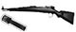 | K43 + GPG40 GranatWerfer  The Engineer's M1 Garand and K43 rifles come with fixed Grenade Launcher attachments. Hitting Alt-Fire (Z) will load a Grenade for firing. After the Grenade is fired, Alt-Fire needs to be pressed again to load another Grenade. Firing Rifle Grenades depletes the Power Bar. You can still fire the rifle normally without a Grenade loaded, but the Grenade Launcher remains attached. Using up your load-out of Rifle Grenades will still leave you your full complement of Hand.

Heavy Weapons (Keyboard 3 or 0)
MG42 machine gun, mounted and mobile
You can fire the MG42 while standing, but your shots will be wildly inaccurate. Go Prone and hit alt Fire to deploy the MG42's bipod; your fire will now be far more accurate.
81mm Morser / 3 Inch Mortar
Both Axis and Allies use variants of the French Brandt 81mm/3 Inch Mortar design. To use the Mortar, hit your Alt Fire Key (Z). Once the Mortar is readied, a Mortar round can be fired by pressing Fire. The elevation (range) and azimuth (lateral direction) of the Mortar can be adjusted by moving the mouse using the crosshairs as a guide. The lower the angle of elevation, the further the Mortar will fire. You can observe your fall of shot either by line of sight or by looking at your Command Map (G). Field Ops may designate targets for your Mortar as they call in Artillery Strikes. A targeting reticule will appear on your Command Map and in your Mortar sights. You can then aim for the reticle, in the knowledge that your Mortar rounds will be falling on the correct bearing, although you may still have to adjust elevation.
Panzerfaust
The Panzerfaust is a disposable one-shot weapon that fires a powerful rocket-propelled grenade with a significant blast radius. Firing the Panzerfaust depletes the Power Bar. It cannot be fired when Prone.
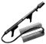 | Flamethrower  The Flamethrower fires a pressurized jet of liquid flame. It can't be partially reloaded; a full tank of fuel must be expended before it can be reloaded.

Explosives
Each type of explosive is used in a different way:
Grenades (Keyboard 4)
Grenades can be thrown immediately by pressing Fire, or press and hold Fire to activate their 5 second timer. You will hear the timer click and at the end of the 5 seconds the Grenade will explode. Be sure to throw the Grenade before the 5 seconds are up or else it will explode, likely killing you.
Dynamite (Keyboard 6)
Dynamite has a 30 second timer. Dynamite is used primarily for destroying objectives. Only Engineers can set and defuse Dynamite. Dropped Dynamite glows yellow. Fused Dynamite glows red and flashes on and off. The rate at which the Dynamite flashes red increases as the timer ticks down.
Satchel Charges and Detonator (Keyboard 6)
Satchel Charges are remote control explosive charges and can only be used by the Covert Ops class. The Satchel Charge Remote Control will indicate when you are close enough to the charge to detonate it by showing a green light. A red light indicates that you are too far away from the charge to detonate it. Engineers can defuse Satchel Charges.
Land Mines (Keyboard 6)
Land Mines can only be planted by Engineers. Players can see their own team's Land Mines marked with flags (Red for Axis, Blue for Allies). Mines planted by the enemy are not marked with flags unless they are spotted by a covert ops on your team. If you step on a Land Mine you will hear a click and hiss as it arms. The mine will only detonate when you step off it. Engineers can defuse mines even while a player is standing on them. Even your own team's Land Mines will kill you. If mines have been detected in the area by a Covert Ops, a message will appear on the screen telling you so.

Mounted and Emplaced Weapons
Browning M1919A4 mounted .30 cal machine gun
The Browning .30 MG is a turret-mounted weapon usable by all classes.
Binoculars (Keyboard B)
The Field Ops and Covert Ops are equipped with Binoculars as part of their initial weapons load-out. Other classes may be rewarded with Binoculars which will allow you to observe distant enemy positions, but not to call in Air Strikes or spot Land Mines.

K. Classes

K.1 Soldier
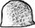
The Soldier is Enemy Territory's Heavy Weapons Specialist. While the Soldier doesn't have any special abilities, he is the only class that can carry heavy two-handed weapons such as the mobile MG42, Mortar, Flamethrower and Panzerfaust. Soldiers initially spawn with a load-out of 4 Hand Grenades.
Heavy Weapons (Keyboard 3 or 0)
The Soldier can choose from one of five weapons to carry in the special weapon slot (3 or 0): The MP40 (Axis) or the M1A1 Thompson (Allies), the Panzerfaust, the Flamethrower, the Mobile MG42 or the Mortar. The Panzerfaust and Mortar use up the Power Bar.

K.2 Medic

The Medic can heal team-mates with Health Packs and revive dead teammates, bringing them back into combat without having to wait for the next respawn. Medics help their teammates keep on fighting. Medics can only carry the M1A1 Thompson or MP40 SMG's and initially spawn with a load-out of one Hand Grenade.

Medic Special Weapons and Items:
Syringe (Keyboard 5)
The Syringe is used to revive teammates (see "Special Abilities" below). When Medics pick up an Ammo Pack, either from a Field Ops or an Ammo Cabinet, they receive 1 extra syringe.
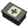 | Health Pack (Keyboard 6)  Like the Field Ops' Ammo Packs, Health Packs can be dropped on the ground by first switching to them (6) and then pressing Fire. Dropping Health Packs depletes the Power Bar which must be at least half full to drop one. Enemies can also pick up your dropped Health Packs.

Medic Special Abilities:
Revive
When a teammate dies, Medics will see a red icon over their body. As long as the icon is there, the Medic can revive them by using the syringe (5). Stand over a teammate to bring up the gray Syringe icon, then press Fire to revive. The icon disappears when the team-mate goes into Limbo. This happens when either the body takes too much damage or when the teammate selects to enter Limbo.

K.3 Engineer
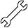
Engineers can set and defuse Dynamite, defuse enemy Satchel Charges, plant Land Mines, build constructible objectives, and repair guns and vehicles. Almost every primary objective in Enemy Territory requires the special abilities of the Engineer. Allied Engineers can choose between the M1A1 Thompson sub machine gun or the M1 Garand rifle with M7 Grenade Launcher. Axis Engineers can choose between the MP40 sub machine gun or the K43 rifle with GPG40 GranatWerfer. Engineers spawn with an initial load-out of 4 Hand Grenades (and 5 Rifle Grenades, if they've chosen that rifle).

Engineer Special Weapons and Items:
Engineer's Tool (Keyboard 5)
The Engineer's Tool is used to arm, defuse, repair and build. A gray Wrench icon appears near the crosshair signal when this tool is necessary. To use, press and hold fire (left mouse button or CTRL) until the blue bar fills.
Dynamite (Keyboard 6)
Press fire to drop the Dynamite and automatically switch to the Engineer's Tool. To arm the Dynamite, Crouch over it, aim the Engineer's Tool at it and hold down fire. A blue bar will indicate your progress.
Land Mines (Keyboard 7)
Land Mines are dropped and armed exactly like Dynamite. Each team has a maximum of 10 Land Mines to place at any one time.

Engineer Special Abilities:
Defuse
Engineers can defuse Dynamite, Satchel Charges and Land Mines. To defuse, equip the Engineer's Tool (5) and position yourself over the item until the gray Defuse icon appears, then use the tool to defuse it. Engineers must remain with their crosshairs aimed directly at the object to defuse it.
Repair
Engineers can repair damaged vehicles and Machine Guns. To repair, simply equip the Engineer's Tool (7) and use by pressing and holding fire until the blue bar fills.
Build
The Engineer can build Command Posts or other constructible objectives in the mission by moving to them so that the gray wrench and hammer of the "Build" icon appear. The item is constructed in the same way an explosive is armed. Use the tool until the blue progress bar is full and construction is complete. While construction is in progress, a translucent image of the complete image will appear.
This is what an objective under construction looks like:
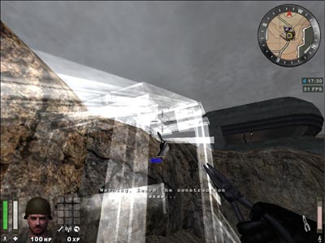

K.4 Field Ops
The Field Operations Specialist or Field Ops is responsible for a team's ammunition resupply and heavy fire support. Field Ops can distribute Ammo Packs to their team-mates so that they can keep on fighting even when their initial load-out is expended. Field Ops can use call in Air Strikes for nearby targets by indicating the target with their Smoke Canister, and use their Binoculars to spot distant targets for Artillery Strikes. Field Ops can only use SMG's and initially spawn with a load-out of 2 Hand Grenades.

Field Ops Special Weapons and Items:
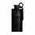 | Air Strike (Keyboard 5)  When thrown, the Smoke Canister will emit colored smoke that will mark an Air Strike target. An Air Strike can only be called if the Power Bar is completely full.
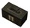 | Ammo Pack (Keyboard 6)  Pressing Fire with the Ammo Pack selected will drop an Ammo Pack. Each Ammo Pack depletes the Power Bar. The Power Bar must be at least half full to drop one. Note that any player can pick up an Ammo Pack, even the enemy.

Field Ops Special Abilities:
Artillery Strike (Keyboard 7)
To call in an Artillery Strike, view the target through your Binoculars and then hit Alt-Fire (Z). Equip your Binoculars by pressing (B) or scrolling through your weapons with your mousewheel. Your Power Bar must be full to call in an Artillery Strike. You will hear an audio cue to confirm whether the target can be hit.
Calling in an Artillery Strike also issues the target's map coordinates to any Soldiers on your team equipped with a Mortar. For the duration of the Artillery Strike, your designated target will appear on their Command Map and Mortar sights as a targeting reticule. Friendly Mortar Soldiers can then direct their firepower on to your target in addition to the Artillery Strike.

K.5 Covert Ops

The Covert Operations Specialist or Covert Ops is Enemy Territory's espionage, reconnaissance and sabotage expert, in addition to being a deadly marksman. His skills are stealing and wearing enemy uniforms, detecting Land Mines and the stealthy sniping of unsuspecting enemies. He can also infiltrate enemy positions by using enemy Team Doors (while disguised), can report vital battlefield intelligence to his team and destroy key targets with Satchel Charges.

Covert Ops Special Weapons and Items:
Smoke Grenades (Keyboard 5)
Smoke Grenades emit a thick smoke screen shortly after being thrown, ideal for blinding defenders and concealing troop movement. If you find yourself pinned down by an emplaced MG nest, a Smoke Grenade is an excellent way of negating its firepower advantage.
Satchel Charges (Keyboard 6)
Satchel Charges are remote-detonated demolition devices. Dropping a Satchel Charge will automatically switch your equipped weapon to the remote Detonator. Pressing fire will now cause the charge to explode. Note that the Satchel Charge detonator is limited by range, but not line of sight. A green lamp on the Satchel Charge Detonator indicates that you're in range and can detonate the charge by hitting your Fire key. A red lamp indicates that you're out of range. Note that enemy Engineers can defuse Satchel Charges.
Binoculars (B or Keyboard 7)
Covert Ops are issued with a pair of Binoculars as part of their initial weapons load-out. See Detection below.

Covert Ops Special Abilities:
Disguise
A Covert Ops can take the uniform off of a dead enemy soldier and wear it as a disguise. To do this, stand over the body of a dead soldier to bring up the gray Uniform icon. Keep Activate (F or Enter) pressed to take the uniform from the soldier and put it on. The fallen enemy soldier's body will remain without pants as a warning to his living team-mates that they have an infiltrator in their midst. While wearing an enemy uniform, the Covert Ops can use enemy Team Doors.
A disguised Covert Ops will remain in disguise as long as they only use Smoke Grenades, Satchel Charges and Satchel Charge Detonators. They will only lose their disguise when using silenced weapons, the knife and Grenades if they do so in an enemy's field of view. This includes the enemy that they are currently engaging, which makes attacking from behind a very crucial tactic.
Players can still identify disguised enemy Covert Ops. Disguised enemy Covert Ops at longer ranges will display the name and rank information of the player whose uniform they've stolen but at close range, disguised enemy Covert Ops will not display ANY name or rank information and may be safely shot.
Detection
The Covert Ops can detect Land Mines, enemy positions and enemy Command Post. To detect Land Mines, use the Binoculars by pressing Alt-Fire (Z) and scan the area. As you scan, you'll see enemy Land Mine indicators. Holding the Binocular crosshairs over it will flag it and broadcast a message to the whole team with the mine's location, as well as mark it on the Command Map. Detected mines can be destroyed with other explosives (Grenades, Rifle Grenades, Dynamite etc). The Covert Ops can also spot enemy positions. Any enemy that the Covert Ops can see is automatically displayed on the Command Map for the rest of the team.

L. Skills and Rewards
Uniquely for a First Person Shooter, Enemy Territory rewards players with Skills, Rewards and Promotions. Each of Enemy Territory's classes has its own specific skill and abilities, in addition to two general skills that apply to all classes: Light Weapons and Battle Sense. For each class, the use of their primary skill (e.g. First Aid for Medics) results in an increase in Experience Points (XP) and at certain levels these result in a Reward.
Players' Battle Sense, Light Weapons and current class skill level are indicated in the HUD display at the bottom left of the screen. Each skill has four Levels. At each Level the player receives a unique reward.
Improvements in a player's general and class-specific skill level are rewarded periodically with promotion to a superior rank. Ranks in Enemy Territory range from Private to General (and their Axis counterparts). Ranks are displayed on the player's helmet for everyone to see. Ranks are a visible warning to the enemy of a player's current skill level and Experience Points. The best player in each class is awarded a medal at the end of each mission.

Light Weapons
 | Light Weapons rewards all player classes for kills with small arms and unscoped rifles. Players earn 3 XP per kill with a grenade, a Legshot, an Armshot or a Bodyshot and 5 XP per kill with a Headshot.
Level 1 Light Weapons: Improved use of Light Weapon Ammunition
When you respawn, your ammo load-out will include one extra clip of ammunition.
Level 2 Light Weapons: Faster Reload
Your familiarity with your weapons allows you to reload your weapons 35% faster.
Level 3 Light Weapons: Improved Light Weapon Handling
Your combat experience allows you to handle your weapons with greater ease; SMG spread is reduced by 35% while Pistol recoil is halved.
Level 4 Light Weapons: Dual-Wield Pistols
Your single-handed weapon slot now has the option of dual-wield akimbo pistols.

Battle Sense
 | Battle Sense is a bravery skill that rewards all classes for surviving combat.  Players gain ZERO points for each 30 seconds survived while 'Cold' i.e. not actively engaged in combat. You'll earn 2XP per 30 seconds while 'Warm' (you inflicted damage), 5XP per 30 seconds while 'Hot' (dealing AND receiving damage) and 8XP if 'Super-Hot' (killing and receiving damage).
Battle Sense Level 1: Issued Binoculars
Battle Sense Level 1 gives you a pair of Binoculars which can be used to reconnoiter enemy positions. Only Covert Ops can use Binoculars to spot Land Mines for their team-mates.
Battle Sense Level 2: Improved Physical Fitness
The powerful aerobic benefits of prolonged combat activity enable your Stamina bar to recharge at 160% of the normal rate.
Battle Sense Level 3: Improved Health
As a wily battle-hardened veteran, your combat expertise effectively increases your maximum Health by 15 points.
Battle Sense Level 4: Trap Awareness
Even if you're not a Covert Ops, you'll be able to sense enemy Land Mines without the aid of Binoculars. Any mines within a certain range will appear as translucent outlines in your field of vision. Unless you're a Covert Ops, you won't be able to spot them for your team-mates.

Heavy Weapons
This rewards players for kills with Heavy Weapons. Players of any class will earn 3XP for a kill using an Emplaced or Mounted MG. Soldiers earn 3XP for kills with the Mobile MG42, Panzerfaust, Flamethrower or Mortar. You earn 3XP whether the kill is due to explosive splash damage or a direct hit.
Heavy Weapons Level 1: Improved Projectile Resources
Your combat experience allows you to use your projectile weapons with greater ease. Firing a Panzerfaust or Mortar will now take 1/3rd less Power Bar than previously.
Heavy Weapons Level 2: Heavy Weapon Proficiency
Your technical know-how means that your overheating Emplaced or Mobile MG will cool at twice the normal rate.
Heavy Weapons Level 3: Improved Dexterity
You've been lugging heavy chunks of metal around the battlefield for so long, your speed penalty is now decreased. You will still be slowed when firing the Flamethrower, but when carrying it or your other weapons - your speed is now faster.
Heavy Weapons Level 4: Improved Weapon Handling
Such is your skill at toting weaponry, you are now able to handle a Light Weapon in one handed slot, freeing up the two handed slot for an alternate Heavy Weapon. This means you can now carry an SMG and a Mortar, for instance.

First Aid
This is a Medic-specific skill that rewards players for reviving team-mates and healing them with Health Packs. Medics earn 1XP each time they heal someone with a Health Pack and 4XP every time they revive another player with their Syringe.
First Aid Level 1: Medic Ammo
Medics receive an extra ammunition clip and grenade with their basic weapon load-out.
First Aid Level 2: Improved Resources
2 syringes extra max ammo, 2 extra on spawn plus Medic pack only takes 15% Power Bar instead of 25%
First Aid Level 3: Full Revive
Syringes now return fallen team-mates to full health.
First Aid Level 4: Adrenalin Self
To equip the adrenalin shot press the Special Weapon 1 key (5 by default) twice and then press the primary fire key to inject the Adrenaline syringe. Doing so will impart a temporary bonus in Health and Stamina. For 10 seconds you will only suffer half damage from any attack but your Stamina Bar will not decrease at all even if you are sprinting. This will give you the ability to rush into and out of strongly defended areas which may prove of critical tactical importance.

Engineering
This is an Engineer-specific skill that rewards players for constructing/demolishing objectives and the use of explosives. Engineers earn 3 XP for repairing a vehicle or MG. They also earn XP for constructing or destroying constructible objectives: 5XP for a 50% of Power Bar objective such as repairing an MG nest, 7.5 for a 100% Power Bar objective like repairing a tank and up to 10XP for destroying an Objective. Engineers also earn 3XP for a Rifle Grenade kill, 4XP for a Land Mine or Dynamite kill, 4XP for defusing an enemy Land Mine and 6 points for defusing enemy Dynamite.
Engineering Level 1: Improved use of Explosive Ammunition
Inventory includes four extra Rifle Grenade rounds and four extra Hand Grenades.
Engineering Level 2: Improved Dexterity
The experience of handling explosives in combat allows Engineers to arm and defuse Land Mines and Dynamite in half the time.
Engineering Level 3: Improved Construction and Destruction
The expertise of the veteran Engineer means that constructing and repairing objects and setting Dynamite or Land Mines uses 1/3rd less Power Bar charge than normal.
Engineering Level 4: Issued Flak Jacket
Only the most expert Engineers who have proven their ability to survive on the battlefield are issued with these expensive Flak Jackets which provides the player with 50% damage deflection from explosive weapons.

Signals
This is a Field Ops-specific skill that rewards players for killing enemy players or destroying objectives with Artillery or Air Strikes, and supplying team-mates with ammo packs. Field Ops earn 1XP for giving one of your team's players an Ammo Pack. You'll earn 3XP for every enemy player you kill with an Air Strike, 4XP for killing them with an Artillery Strike and 5XP for destroying an Objective with either.
Signals Level 1: Improved Resources
Your proven logistical efficiency is rewarded by access to Improved Resources. Every Ammo Pack you distribute will contain an extra magazine clip and issuing the Ammo Pack will only deplete your Power Bar by 15% instead of 25%.
Signals Level 2: Improved Signals
Your experience as a fire support observer gains you improved efficiency. Calling in an Artillery or Air Strike uses up only 2/3 of your Power Bar, allowing you to call in fire support more frequently than before.
Signals Level 3: Improved Air and Ground Support
Your expertise in identifying key enemy targets is rewarded by diverting more fire support resources to your designated targets. Each Air Strike now has two aircraft incoming and each Artillery Strike lasts twice as long.
Signals Level 4: Enemy Recognition
Your observational skill and battlefield experience now means that you can identify disguised enemy Covert Ops. Placing your cross-hairs over an Enemy infiltrator will result in a Disguised Enemy prompt and their location will be highlighted on your team's Command Map.

Covert Operations
This is a Covert Ops-specific skill group, which rewards players for reconnaissance, reporting battlefield intelligence, sabotage and Scoped Weapon skills. ANY player earns 5XP for kills with a headshot, 3XP for kills with a bodyshot, armshot or legshot. A Covert Ops will earn 3XP for each Land Mine spotted and 5XP for disguising themselves using an enemy uniform. You'll earn 5XP for every kill with a Satchel Charge and 7XP every time you use a Satchel Charge to destroy an Objective.
Covert Operations Level 1: Improved Use of Scoped Weapon Ammunition
Each Ammo Pack you get from a Field Ops or Ammo Cabinet includes one extra clip of ammunition for your Scoped Weapon
Covert Operations Level 2: Improved use of Sabotage and Misdirection
Your expertise allows you to use your Satchel Charges and Smoke Grenades more often: your Power Bar usage will be reduced by 1/3rd.
Covert Operations Level 3: Breath Control
Your mastery of the Sniper's art results in a 50% reduction in both recoil jump and weapon sway with Scoped Weapons.
Covert Operations Level 4: Assassin
Your expertise with the knife allows you an instant kill with any backstab.

M. Ranks, Stats, and Medals

M.1 Ranks
Axis | Allied | Insignia
Schutze (Stz) | Private | (none)
Oberschutze (Otz) | Private 1st Class (PFC) | 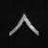
Gefreiter (Gfr) | Corporal (Cpl) | 
Feldwebel (Fwb) | Sergeant (Sgt) | 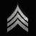
Leutnant (Ltn) | Lieutenant (Lt) | 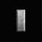
Hauptmann (Hpt) | Captain (Cpt) | 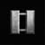
Major (Mjr) | Major (Maj) | 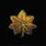
Oberst (Obs) | Colonel (Cnl) | 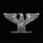
Generalmajor (GMj) | Brigadier General (BGn) | 
Generalleutnant (GLt) | Lieutenant General (LtG) | 
General (Gnl) | General (Gen) | 

Stats
The End Results show the best players from either team in each field of achievement in that map. Medals are awarded to a team's best player in each category. Medals are per team, End Results are overall.
Highest Fragger: most kills
Highest Experience: highest XP
Highest Ranking Officer: highest rank
Most Highly Decorated: most medals
Highest Battle Sense: highest Battle Sense
Best Engineer: Best Engineer
Best Medic: Best Medic
Best Field Ops: Best Field Ops
Best Light Weapons: Best Light Weapons
Best Soldier: Best Soldier
Best Covert Ops: Best Covert Ops
Highest Accuracy: Best ratio of shots fired to hits
I Ain't Got No Friends Award: Most team kills
Welcome Newbie: Lowest score under 100

The Medals System
Players on each team will be rewarded at the end of each match with Medals for outstanding performance. The best player in each class on each team will receive the class medal. There are also medals for Highest Battle Sense and Highest Light Weapons.
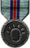 | Highest Battle Sense
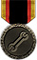 | Best Engineer
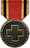 | Best Medic
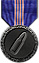 | Best Field Ops
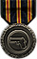 | Highest Light Weapons
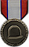 | Best Soldier
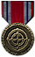 | Best Covert Ops

N. Communication
Success on the battlefields of Enemy Territory will depend on your ability to Cooperate, Coordinate and Communicate. Time spent familiarizing yourself with the Voice-Chat keys in particular will greatly increase your enjoyment and success in the game.
Command HQ VO
As you play, you will hear audio messages from your Command HQ, informing you as to the state of the map's objectives, and what you should do next.
Say
Hit (Keyboard T) and anything you type will appear as a textline to all players on your server. Global Say text appears in Green.
Team Say
Hit (Keyboard Y) to type text messages that only members of your team will be able to see. Team Say text appears in Blue.
Voice Chat
Hit (Keyboard V) to bring up the Voice Chat menu. Voice Chat allows you to play audio messages.
Fire Teams
As soon as you join a map you'll be prompted if you want to create or join a FireTeam. FireTeams allow you to closely coordinate several different players all over the map. Selected members of your FireTeam will have a large icon over their heads to aid identification. You can send detailed tactical instructions to only your FireTeam and not the rest of your team by using the FireTeam Say or Voice Chat menu.
FireTeam Say
Hit (Keyboard U) to type text messages to only members of your FireTeam. FireTeam Say text appears in Yellow.
FireTeam Voice Chat
Hit (Keyboard Z) to bring up the Voice Chat menu. This allows you to play audio messages to only the players on your FireTeam.
Calling Votes
Players can call votes to change many options on the game server. If a player has called a vote, the voting message will appear in yellow text on the left side of the screen. To vote, press F1 for "yes" or F2 for "no". To call a vote, press the (ESC) key and click on the Vote button. The voting options include:
- Misc
- Map
- Players
Within each of these categories a variety of votes can be called. The options are self explanatory.

O. Servers
To play Enemy Territory, you must either join a server or start your own. Here's a quick guide to finding servers or creating your own.

0.1 Finding a Server
When you first start Enemy Territory, click the "Play Online" option to find a server. You'll be taken to the server browser screen. Here's an explanation of the server browser components.
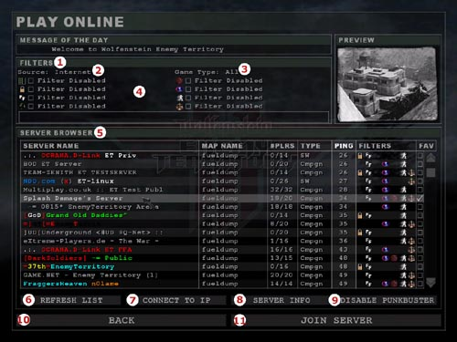
1. Filters
In the "Filters" section, choose what type of servers you want displayed:
2. Source: displays Local, Internet, or Favorite servers. Click to change.
3. Gametype: displays only servers running the selected gametype, or "All". Click to change.
4. Filter checkboxes: filters out the following servers from the list - empty or full servers, password-protected servers, servers with Friendly Fire off, max lives enabled, Weapons Restrictions, PunkBuster protected, Anti-Lag and Balance Teams enabled.
5. Server Browser
Below the Filters is the server list itself. The list can be sorted according to server name, map name, players, gametype, ping, or filters. You can sort by a specific column by clicking on the column header you wish to sort by. Clicking a server will select it.
6. Refresh List
This will re-query the master server, generating a new, updated list of servers according to the filters set.
7. Connect to IP
This allows the user to enter the IP address of a specific game server.
8. Server Info
This will show you every detail of the Server's settings, rules and configuration. It will also show you the current players on the server.
9. Enable/Disable PunkBuster
PunkBuster is a powerful cheat protection technology that prevents dishonest players from gaining an unfair advantage. PunkBuster is NOT enabled by default. Click this button to enable or disable it. Note: many servers will not allow you to join if PunkBuster cheat protection is not enabled.
10. Back
This button brings you back to the main screen.
11. Join Server
After selecting a server in the server browser, click "Join Server" to begin playing.

Creating a Server (using the Menu)
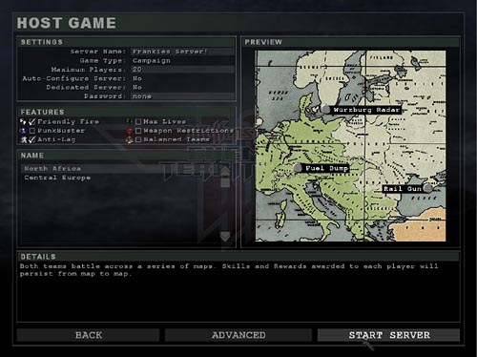
Hosting Dedicated Servers
There are two types of servers you can create to run Enemy Territory: Listen servers and Dedicated servers. Listen servers allow you to play the game and host it at the same time, while Dedicated servers only host the game. Dedicated servers use fewer resources than Listen servers, and are therefore more stable to play on. Listen servers work well if you're playing on a LAN.
To create a server, click on "Host Game" at the main menu. The "Host Game" screen contains a number of options that allow you to configure the server.
Settings
This area allows you to configure the server properties - game type, server name, PunkBuster protection, and more.
Gametype
As you change the game type, a list of available maps will appear. Click a map to select it. In Campaign mode, you can select a campaign, which consists of the three maps shown in the right-hand window.
Details
This window contains a description of the map and its objectives.
Advanced
Clicking this button will take you to a screen that allows you to set more advanced options, such as the Message of the Day, remote console passwords, and more.
Start Server
Once you've configured the server, click this button to start it.
**For more indepth information on creating a server, please see the file named Server Setup located in the Docs file.**

P. Credits

Splash Damage Credits
Paul 'Locki' Wedgwood | Game Designer / Managing Director
Francisca 'Freya' Wedgwood | Business Director

Art
Richard 'Fluffy_gIMp' Jolly | Lead Artist / Creative Director
Francis 'Frankie' Hobbins | Artist / Animator
Per 'Per128' Abrahamsen | Additional Art

Programming
Arnout 'RR2DO2' van Meer | Lead Programmer
Gordon 'digibob' Biggans | Programmer
Randy 'ydnar' Reddig | Programmer / Artist

Design
Tim 'Marauder' Kautz | Designer / Audio Engineer
Edward 'Bongoboy' Stern | Designer / Writer

Level Design
Matt 'Wils' Wilson | Lead Level Designer
Simon 'sock' O'Callaghan | Senior Level Designer
Mark 'nakedape' Fry | Designer / Writer
Thomas 'Q-Fraggel' Creutzenberg | Level Designer
Chris 'SHoD' Farcy | Level Designer / Artist
"Lloyd 'LloydM' Morris | Level Designer
Lee 'Llama' Mercer | Additional Level Design

Activision Credits
Jonathan Moses | Producer
Doug Avery | Associate Producer
John Fritts | Installer
Steve Holmes | Production Coordinator
Matthew Beal | Production Tester
Laird M. Malamed | Sr. Executive Producer
Mark Lamia | VP North American Studios

Brad Saavedra | QA Project Lead
Evan Button | QA Project Lead
Matt McClure | QA Senior Project Lead
Nathaniel McClure | QA Floor Lead
QA Testers: Matt Nelson, Shane Sasaki, Erik Melen, Erik Beaumont, Sean Berrett, Mike Castillo - Walsh, Randolph L. S. d'Amore, Andrew S. Molloy, Robert Max Martin, Julian Dimarco, Ayal Moreno, Charlie Staples, James White, Paul Fortin, Lawrence Wong, Chris Wagener, Kyle C. Jackson, Paul Goldilla, Cory Rice, Stephen Peterson and Daniel Kannard
Chris Keim | Network
Neil Barizo | Compatibility
Marilena Rixford | QA Manager
Tim Vanlaw | Manager, Code Release Group
Jason Levine | Sr. Lead, Code Release Group
Jef Sedivy | Lead, Code Release Group
Bob McPherson | Manager, Customer Support

Code Release Group Testers: Douglas Todd, Mike Restifo and John Call

Id credits
Kevin Cloud | Executive Producer
Timothee Besset | Additional Programming

Wolfenstein: Enemy Territory is powered by id Software's Quake III Arena (TM) technology.

Production, development and technical assistance provided by id Software.

PunkBuster by Even Balance, Inc.
Tony Ray | President
Bjorn Christoph | Senior Project Leader

Research / Technical
Brett Lentz
Paul Seal
Ryan Mannion
Jason Roman
Daniel Ferguson
Wouter Tromp
Barry Worthy
Mat Collins

User Support / Documentation
Ken Creedon
Stuart Dunsmore
Jason Allison
Hendrik Thole
Kim Andersen
Dougald Beaudoin
Additional Credits
Drew Markham - Voice of Allied / Axis soldiers
Neil Ross - Voice of Axis Commander
Granville van Dusen - Voice of Allied Commander
Nerve Software - Intro Movie Masters
Return to Castle Wolfenstein was developed by Gray Matter Studios & Nerve Software. We would like to thank both developers for their help and support during the development of Wolfenstein: Enemy Territory.
©2003 Id Software, Inc. All rights reserved. Wolfenstein: Enemy Territory, Return to Castle Wolfenstein, the Return to Castle Wolfenstein logo.

